**. Grayscale Conversion**

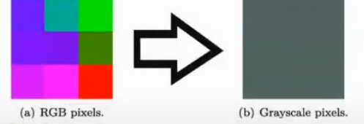

**🔹 What is Grayscale Conversion?**

* A **color image** is usually represented in **RGB (Red, Green, Blue)** channels.
* Each pixel has 3 values:  
  [  
  (R, G, B)  
  ]  
  Example: A red pixel may be (255, 0, 0).
* In grayscale, each pixel has **only one intensity value** (0 = black, 255 = white).

So grayscale is like **compressing 3 channels into 1 channel**.

**🔹 How the Picture Explains It**

1. **(a) RGB Pixels (Left side)**
   * The colorful block image represents pixels in 3 channels (Red, Green, Blue).
   * Each square has a different mix of RGB values.
2. **Arrow (→)**
   * Shows the **conversion process**: combining RGB channels into a single intensity channel.
3. **(b) Grayscale Pixels (Right side)**
   * The output has no color, only shades of gray.
   * Each gray value is computed as a **weighted sum of R, G, and B**.

**🔹 Formula for Conversion**

The most common formula is:

[  
Gray = 0.299 \times R + 0.587 \times G + 0.114 \times B  
]

👉 Why weights?

* The human eye is more sensitive to **Green**, less to **Red**, and least to **Blue**.
* That’s why **G has the highest weight (0.587)**.

Example:

* Pixel = (R=100, G=150, B=200)
* Gray = 0.299×100 + 0.587×150 + 0.114×200
* Gray ≈ 140 (a medium gray pixel).

**🔹 Why Use Grayscale?**

* Reduces **data size** (1 channel instead of 3).
* Easier for **image processing tasks** (like edge detection, thresholding).
* Keeps important **luminance information** but removes unnecessary color.

✅ **In summary (picture-wise)**:

* Left block (RGB) → has 3 values per pixel.
* Arrow → represents merging R, G, and B.
* Right block (Grayscale) → only 1 value per pixel (intensity).

Would you like me to also **make a Markdown note (like I did for Otsu’s Binarization)** for this grayscale conversion explanation with your image at the top?

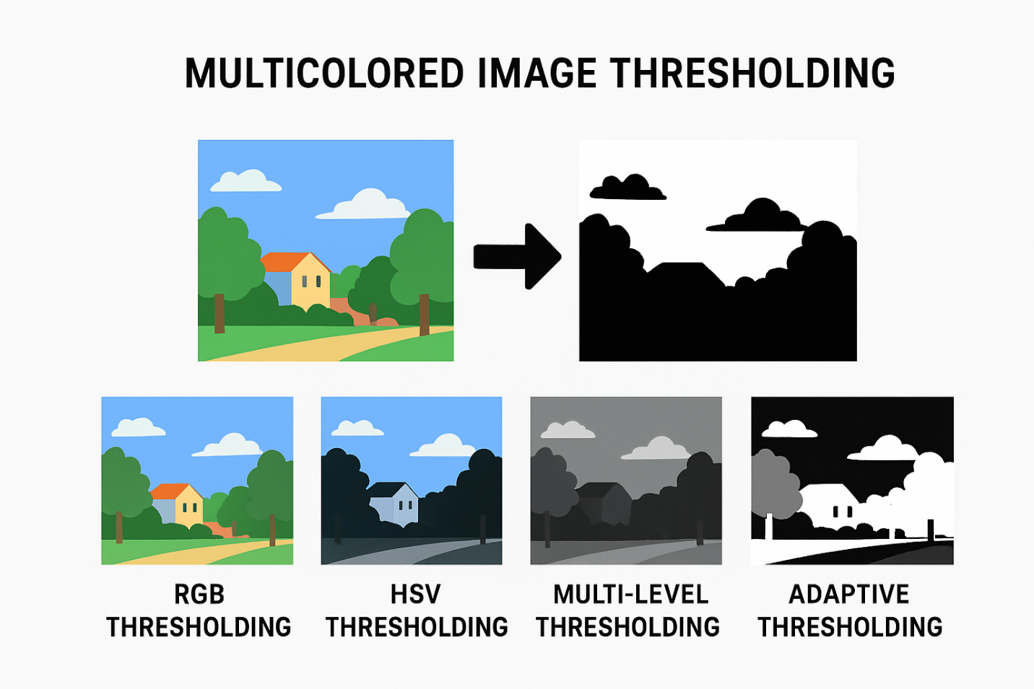

# **🌈 Multicolored Image Thresholding (Detailed Explanation)**

## 🔹 1. What is Thresholding?

Thresholding is a **segmentation technique** in image processing.

* It converts an image into **binary (black & white)** or into **segments** based on pixel intensity.
* Simple thresholding is easy in **grayscale images** because every pixel has a single value (0–255).

But for a **multicolored (RGB) image**, things are more complex, since each pixel has **3 values**:  
[  
(R, G, B)  
]

## 🔹 2. Why Threshold Multicolored Images?

* To extract objects of a **specific color** (e.g., find red cars, green plants, blue sky).
* To **separate regions** based on color ranges instead of just brightness.
* Useful in **computer vision tasks** like object detection, tracking, and recognition.

## 🔹 3. Challenges in Multicolored Thresholding

* **RGB is not perceptually uniform**:  
  A small change in R, G, or B does not always match how humans perceive color.
* Shadows, lighting, and reflections affect color distribution.
* A direct threshold on R/G/B channels often fails.

## 🔹 4. Color Spaces for Thresholding

Instead of RGB, we often convert the image into other **color spaces**:

1. **Grayscale** → simplifies to intensity, but loses color information.
2. **HSV (Hue, Saturation, Value)** →
   * Hue → color (0–179 in OpenCV).
   * Saturation → vividness.
   * Value → brightness.  
     👉 Very useful for detecting specific colors.
3. **Lab Color Space** → separates lightness from color info.
4. **YCrCb** → separates luminance (Y) from chrominance (Cr, Cb).

## 🔹 5. Methods of Multicolored Thresholding

### ✅ (A) **Channel-Wise Thresholding (in RGB)**

* Apply threshold separately on **R, G, and B channels**.
* Example:
  + Extract red objects → set threshold:  
    [  
    R > 150,; G < 100,; B < 100  
    ]
* Works, but sensitive to lighting.

### ✅ (B) **HSV Thresholding** (Most Common)

* Convert image from RGB → HSV.
* Define ranges for the desired color.  
  Example: Red object detection →  
  [  
  Hue \in [0, 10] \cup [160, 180],; Sat > 100,; Value > 50  
  ]
* Create a mask → only pixels in this range are kept (white), others black.

### ✅ (C) **Multi-Level Thresholding**

* Instead of **one threshold**, divide into **multiple ranges**.
* Example:
  + 0–85 → Black (Dark region)
  + 86–170 → Gray (Mid region)
  + 171–255 → White (Bright region)
* For multicolored → apply separately in each channel or HSV hue.

### ✅ (D) **Adaptive Thresholding (on Color Channels)**

* Adjusts threshold **locally** instead of globally.
* Helps when illumination changes across the image.

### ✅ (E) **Otsu’s Method (Extended to Colors)**

* Otsu’s method works on grayscale.
* For colors, you can:
  + Convert to grayscale and apply Otsu.
  + Or apply Otsu separately on each channel.

## 🔹 6. Visual Example (Conceptual)

* **Original Multicolored Image** → RGB with sky, trees, and buildings.
* **RGB Thresholding** → extract pixels with high R, low G, low B (red objects).
* **HSV Thresholding** → detect sky by setting hue range for blue.
* **Multi-Level Thresholding** → divide colors into regions (dark, mid, bright).

## 🔹 7. Applications of Multicolored Thresholding

1. 🚗 **Traffic Systems** → Detect red/green lights, lane markings.
2. 🌱 **Agriculture** → Segment healthy (green) vs diseased (yellow/brown) leaves.
3. 🧑‍🤝‍🧑 **Face Detection** → Skin color thresholding in HSV.
4. 📦 **Industrial Automation** → Color-based product sorting.
5. 📸 **Object Tracking** → Follow colored markers in sports/robotics.

## ✅ Summary

* **Thresholding in multicolored images** means separating objects by **color ranges**.
* RGB is not always the best; **HSV** or **Lab color spaces** are preferred.
* Methods: Channel-wise, HSV thresholding, multi-level, adaptive, or Otsu-based.
* Widely used in object detection, tracking, and segmentation.

# 

# 

# 

# **🔹 What is Masking?**

**Masking** means **selectively processing or extracting parts of an image** using another image (called a **mask**) as a filter.

Think of it like a **stencil**:

* The **mask** controls which parts of the original image are **visible** or **processed**.
* Typically, the mask is a **binary image**:
  + White (255) → Keep/show/process this part of the image.
  + Black (0) → Ignore/hide this part of the image.

But masks can also be **grayscale** or **multi-channel**, depending on the operation.

# 🔹 How Masking Works (Step-by-Step)

1. **Original Image**:
   * A colored or grayscale picture (e.g., a person, object, or scenery).
2. **Mask Image**:
   * Same dimensions as the original image.
   * Values decide which pixels in the original image are "visible" or "used".
3. **Apply Mask**:
   * Pixel-wise multiplication is performed:  
     [  
     Output(x,y) = Original(x,y) \times Mask(x,y)  
     ]
   * Where Mask is usually **0 or 1 (or 0 and 255 in OpenCV)**.

# 🔹 Types of Masking

### 1. **Binary Masking**

* Mask values: **0 or 255**.
* White → Keep pixel.
* Black → Discard pixel.

👉 Example: Extracting a person from a background.

### 2. **Grayscale Masking (Soft Masking)**

* Mask values: **0–255**.
* Pixel intensity determines **transparency**:
  + 0 → fully hidden
  + 255 → fully visible
  + In-between → partially visible

👉 Example: Smooth blending between images (like alpha blending).

### 3. **Channel-wise Masking**

* Masks can be applied to **specific channels** (R, G, or B).
* Useful in color-based segmentation (e.g., isolating only red objects).

### 4. **Logical Masking**

* Instead of a ready mask image, you create a mask using **conditions**:
  + Example:
  + Mask = (image > 100) & (image < 200)
  + This extracts pixels that fall within a certain intensity range.

👉 Example: Isolating bright regions of an X-ray.

# 🔹 Applications of Masking

1. **Image Segmentation** → Keep only objects of interest.
2. **Background Removal** → Make background transparent.
3. **ROI Extraction (Region of Interest)** → Process only a selected region.
4. **Image Blending** → Combine two images with smooth edges.
5. **Feature Highlighting** → Highlight eyes, cars, tumors, etc.
6. **Color Isolation** → Show only one color (e.g., keep red, turn others gray).

# 🔹 Example Visualization

Imagine you have this scenario:

1. Original image → A fruit basket.
2. Mask image → A binary mask highlighting only apples.
3. Output → Only apples remain visible; everything else becomes black.

# 🔹 Mathematical View

If:

* **I(x,y)** = original image pixel at (x,y).
* **M(x,y)** = mask pixel at (x,y).

Then:  
[  
O(x,y) = I(x,y) \cdot \frac{M(x,y)}{255}  
]

* If ( M(x,y) = 0 ) → output = black.
* If ( M(x,y) = 255 ) → output = original pixel.
* If ( M(x,y) \in (0,255) ) → partial blending.

# 🔹 Real-World Examples

* **Medical Imaging** → Mask tumors in MRI scans.
* **Self-driving Cars** → Mask out road lanes or pedestrians.
* **Augmented Reality (AR)** → Mask a person to replace background with animation.
* **Photography** → Selective coloring (make everything B&W except one color).

✅ **In summary**:  
Masking is like using a **filter/stencil** on an image that decides which parts are visible or processed. It’s pixel-wise, highly flexible, and widely used in computer vision for segmentation, background removal, blending, and highlighting features.